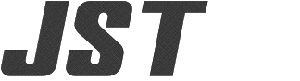 | No.  SCPOP2026722--I | Date Issued:  July 22, 2026
Title of Document:  Report for iLenSys Technologies Private Limited. | Revised: | Date Revised:
Title Subject: Stockholm Convention on POPs Compliance |  | Issued by:  Guntersville Engineering Center

1. Part Number(s) or Series

JST Part Number: | Customer Part Number (if applicable):
ASSHSSH28K51
2. Chemical substance for investigation

https://www.pops.int/TheConvention/ThePOPs/AllPOPs/tabid/2509/Default.aspx

3. Result investigation
This is to report that the three substances of the Stockhom Convention are not intentionally used in the products listed above.
Packaging materials shall not be subject to the survey.

